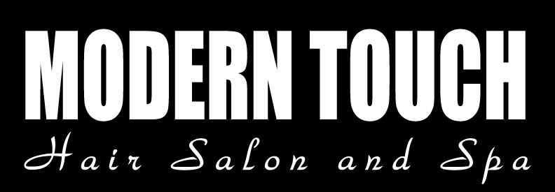
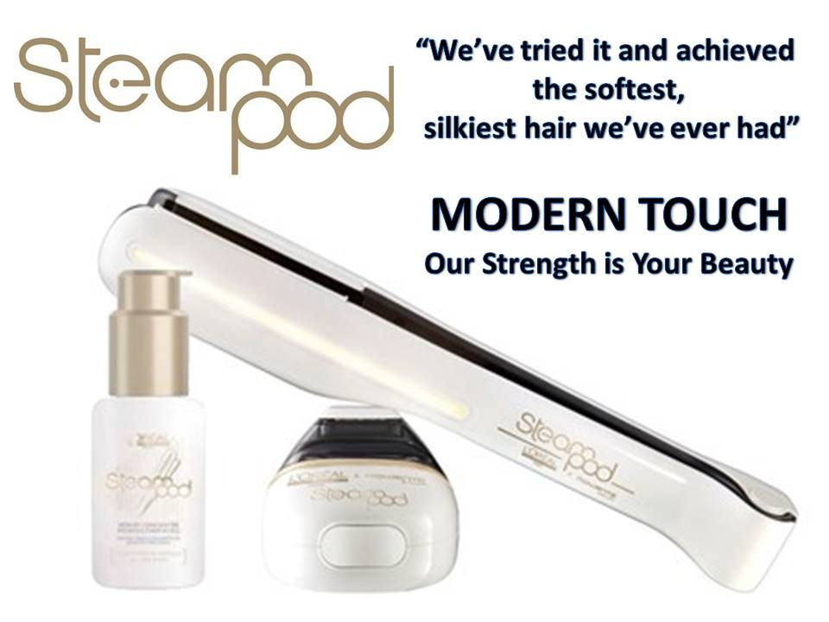
Coupon valid only at Modern Touch Pickering location.
The value of the Coupon is $30.00. No cash value.
Free Coupon valid only in conjunction with any Hair Service which includes wash and style.
One Coupon per customer.
Offer available for a limited time.
Not valid with any other promotion.
Contact salon for appointment - 905 619 0800 or request an appointment by visiting our website.

